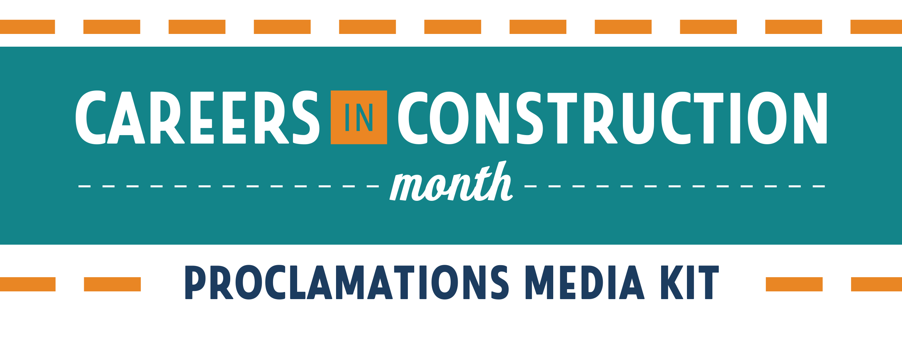

What is Careers in Construction Month?
Careers in Construction Month is an annual month-long celebration of craft professionals and the career opportunities in the construction industry.
Every October, organizations around the country work together to raise awareness of the great careers in construction.
During #CICM, we highlight the skilled men and women who build America, provide information and resources for educators and industry representatives, and inspire the youth of today to choose a rewarding career as a craft professional.
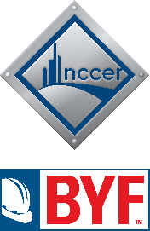
Jennifer Wilkerson - jwilkerson@nccer.org
Director of Marketing, PR & Build Your Future

Rob Kirk - rkirk@nccer.org
Build Your Future Manager

Rachel Burris - rburris@nccer.org
Communications Manager

We ask ALL 50 STATES & U.S. TERRITORIES to proclaim Careers in Construction Month through their local governments!

How to Get Involved

1 - File a Proclamation Request
Organizations or individuals can file a request with their state/territorial government to officially proclaim October as Careers in Construction Month.
- Download the State Proclamation Guidelines for instructions on how to file a proclamation request in your location.
- The earlier you file, the better chance you have for the request to be approved!
- Once you file, email proclaim@nccer.org and let us know so we can update our Careers in Construction Month Map!
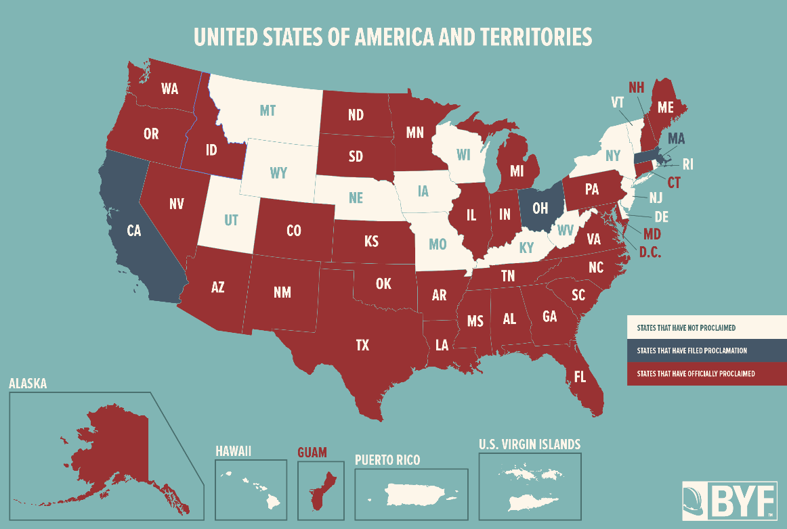

2018 CICM Proclamations Map
What color will your state be in 2019?

2 - Submit Your Proclamation
When you receive the official proclamation of Careers in Construction Month from your government, congratulations! Now it’s time to submit your proclamations.
- Let us know your state has officially proclaimed by emailing proclaim@nccer.org.
- Include a photo of your proclamation document so we can include it in our CICM Proclamations Facebook Photo Album.
- The first 8 organizations to submit their state’s official proclamation will receive a Build Your Future Prize Pack!
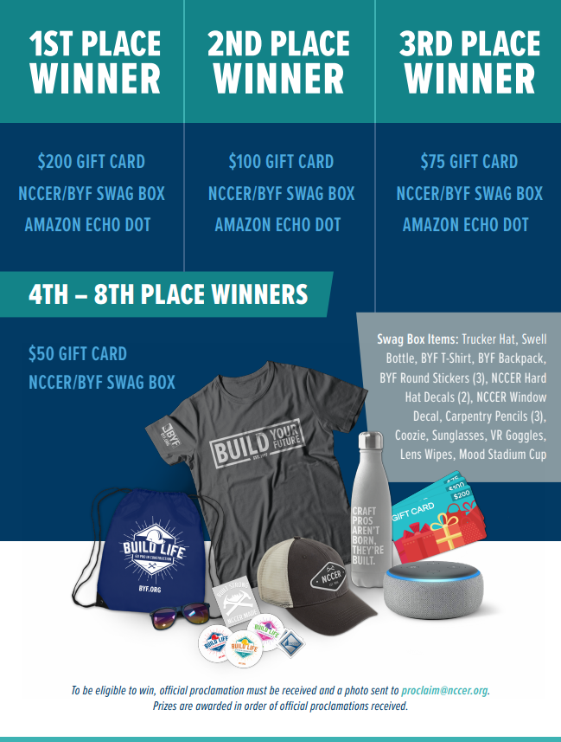
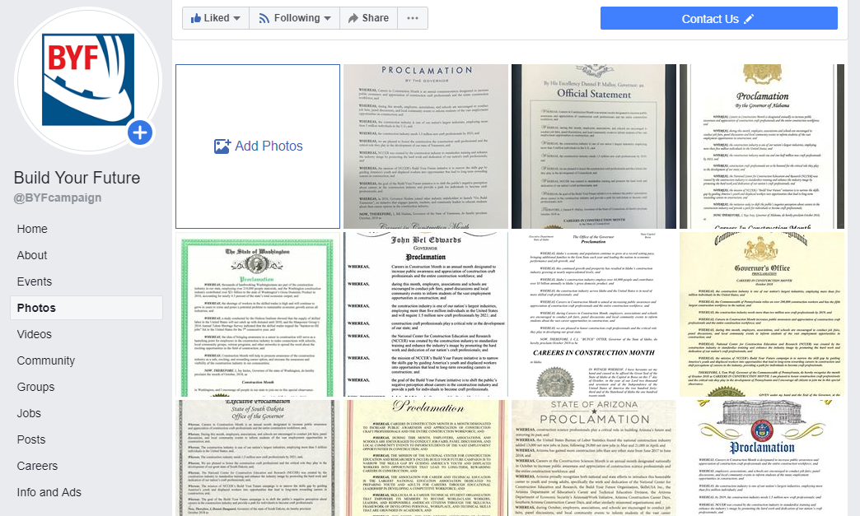
WIN
PRIZES
Get featured on FACEBOOK

3 - Get Social
Help us spread the word about Careers in Construction Month on social media!
- Use the hashtag #CICM.
- Share that you’ve filed and proclaimed CICM in your state.
- Download and post the CICM social graphics, including the exclusive special graphics we will provide directly to filing organizations!

Example Social Posts

Our state is celebrating Careers in Construction Month this October – is yours? #CICM byf.org/CICM

Proclaim October as Careers in Construction Month in your state! Visit byf.org/CICM to learn how. #CICM

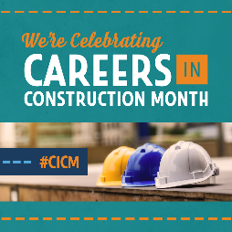
We can’t wait to celebrate careers in #Construction this October! Learn how to get involved at byf.org/CICM #CICM

October is Careers in Construction Month! Check out byf.org/CICM for ideas on how to celebrate #CICM!
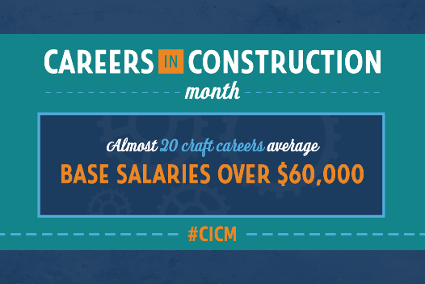

Follow Build Your Future

Build Your Future
@BuildYourFuture
@DiscoverBYF
Build Your Future

Ctrl+Click Here to
DOWNLOAD
GRAPHICS

Shareable Graphics
DOWNLOAD GRAPHICS AT
[INSERT LINK]
